Business Travel Online Application Guidelines

All the foreign faculties at SCU could apply business travel on line, and there is no need to deliver paper materials to our office any more. Please read the guidelines carefully and if you have any problem with this online application process, please contact with us directly.

1. Required Materials for Application
1. A copy of your Invitation letter. The date of your visit must be clearly described in the letter, besides, there must be a signature of your inviter. (If the invitation letter is non-English version, please translate it into English or Chinese).
2. A copy of the Publicity Information Form. The template is given behind and please sign your name on it and a seal of your college is also required.
3. Itinerary for this trip is required. (Flight information/date of entry and departure/ activity contents)
4. A copy of your passport (your personal information page).

Time needed for application procedures
In order to ensure that you can get the reimbursement approval documents in time, please apply online as early as possible.
Usually, it will take 10 workdays since you submit your application online, however it might take more time if you submit your application in summer and winter vacation.

Visa
Application for a visa: if a visa is needed, please check the visa application procedures on the Embassy or Consulate’s website of your destination country.

Contact with us
Address: Administration Service Center for Overseas Affairs (外事办证服务中心), 1st Floor, West Overseas Students Dormitory, Wangjiang Campus.
Work Hours: Monday-Friday 8:30am-12:00pm; 14:30pm-6:00pm.
Summer/Winter Vacation: every Tuesday and Thursday. 9:00am-11:30am, 15:00pm-17:30.
Mrs. Gao
Tel: 028-85467116 or 028-85462991

If you have any problem with your application, please ask the foreign affairs secretary in your own college for help. Thank you for your cooperation!

Business Travel Online Application Process

- Click the Link as below:

http://noa.scu.edu.cn/login.jsp;jsessionid=51C71F5A4642ECCD50B983C0112E57A9

- Log in: User Name is your Campus Card Number and the original password is scu123
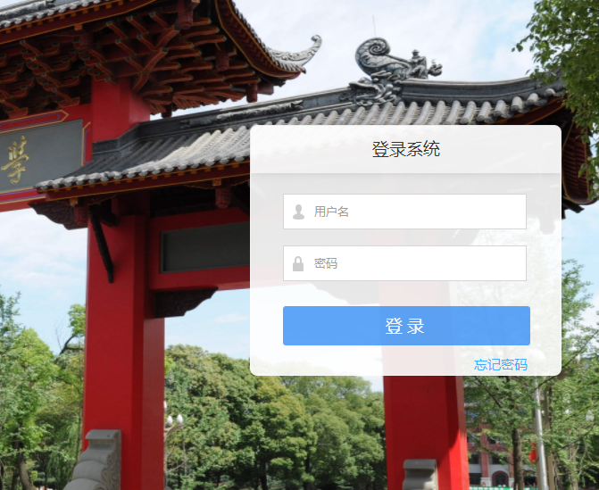

- Click the second button on the top and then choose the fifth option in the third Colum.
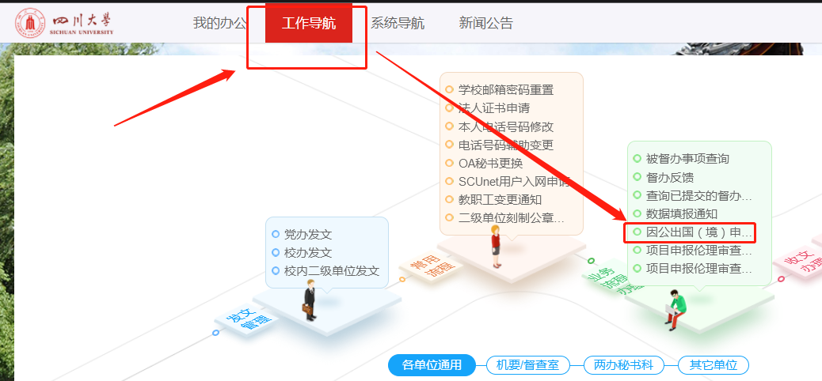

- You will find the application access on the web’s right side.
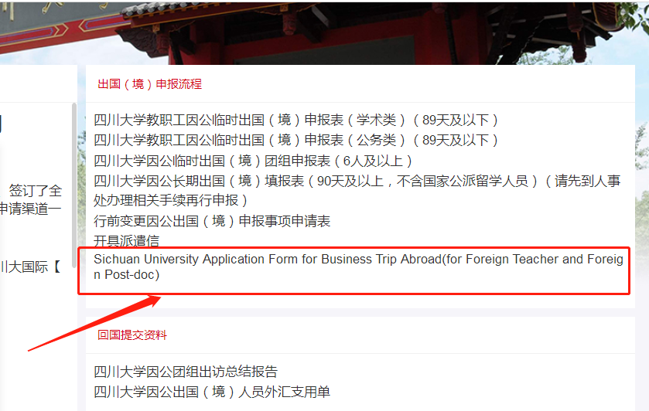

- Please read the guidelines carefully and prepare those materials related with your application.
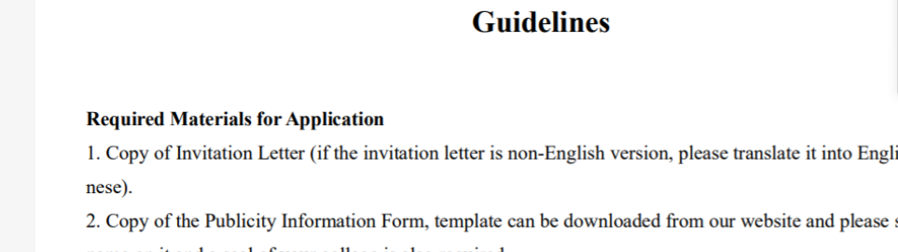
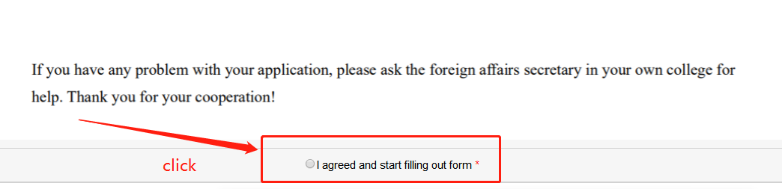

- Complete the form and upload those related materials online.
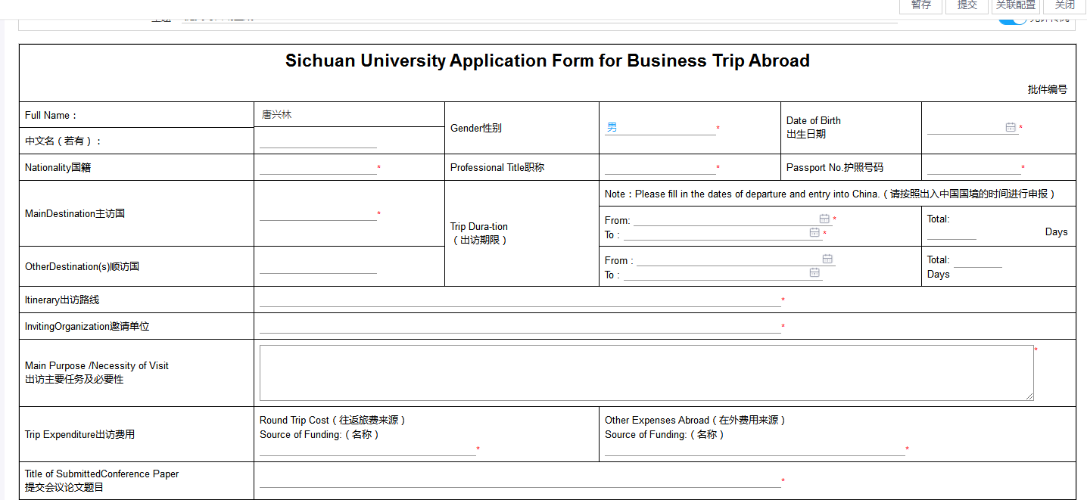
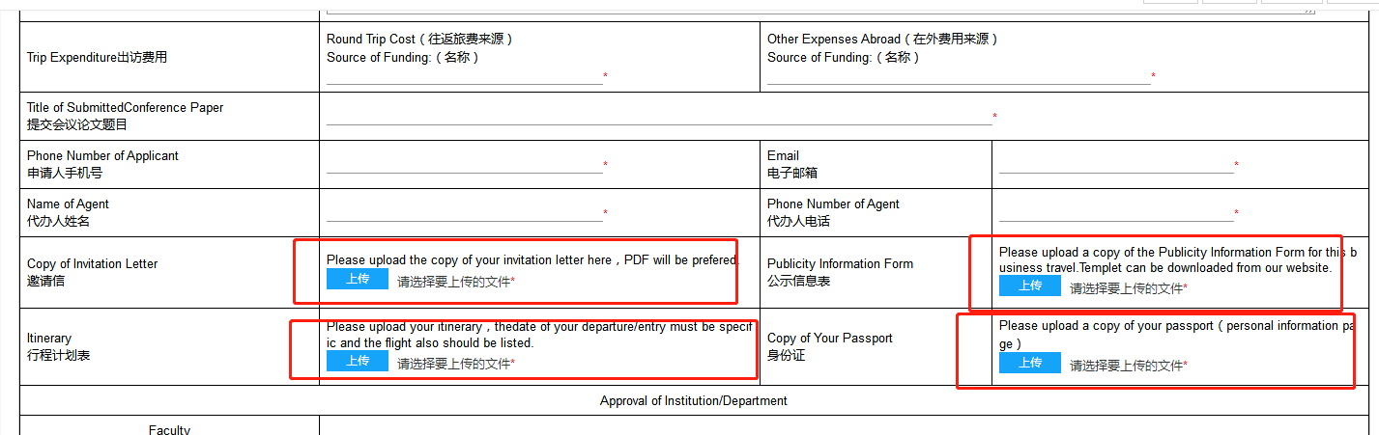

- After you finished this form, please click the second button on the right top side.
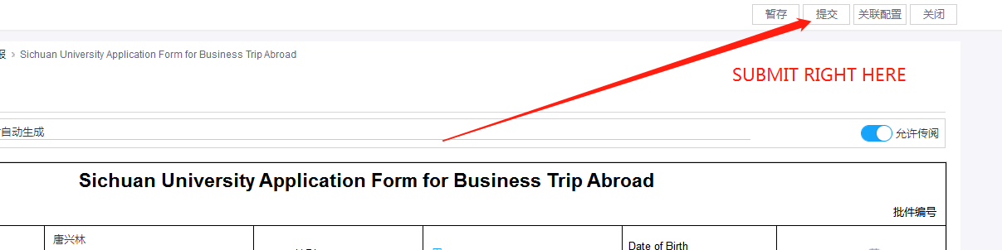

- We will inform you via phone call or short messages, please wait patiently.

Template of Publicity Information Form and Itinerary are attached as below.

四川大学因公出国（境）公示信息表
组团单位：四川大学 |  |  |  | 联系人： 电话：
公示地址： |  |  |  | 公示时间： 年 月 日至 年 月 日
团组  人员  名单 | 姓名 |  | 单位 |  |  |  | 职务及职称
预计出访时间： |  |  | 在外天数： |  |  | 出访国家/地区：
经费来源： |  |  |  |  |  | 预算金额（每人）：
邀请单位：
往返路线：
出访
任务
备注事项： |  |  |  |  | 团长审核签字：
所在单位盖章 |  |  |  |  | 任务审批监督电话：  028-85467116（国际合作与交流处）

- This form should be correctly filled and post on the bulletin board in your college for at least 5 workdays. Since this form is required to be in Chinese, if you have any difficulty with filling this form, please ask your college’s Foreign Secretary for help.

Business Trip Abroad Itinerary (Name)
Days | Dates | Activity Contents
DAY 1 | Date | Outbound Flight Number： ，  Departure City： ， Departure Time： ，  Arrival City： ；  Transit City(if any):___________
DAY 2 | Date | A brief introduction of your schedule in these blanks.
…… | ……
…… | …… | You could add more blanks, if you need.
DAY__  （N/N-1） | Date | Return Flight Number： ，  Departure City： ，Departure Time： ，  Arrival City(China)： ；Arrival Time：  Transit City (if any) :___________
DAY__  (N) | Date  Beijing Time | The day you enter into China mainland Customs.
- Please note that the flights are which you probably plan to book, not need to be the accurate ones.
- Please do not stay in the transit city, the accommodation expense occurred in transit city will not be allowed for reimbursement.
- Please do not exceed the total number of days officially approved. The day of entry and exit are also included.

