University of Chicago Data and Policy Summer Scholar Program
芝加哥大学数据与政策暑期学者项目简介

芝加哥大学数据与政策暑期学者项目（UChicago Data and Policy Summer Scholar Program）是芝加哥大学最新开设的面向国际本科生的暑期项目。在四周的时间中，来自全球各地的优秀本科生将齐聚芝加哥大学，系统学习统计学、计算机编程应用、社会科学研究方法、公共政策以及英语沟通与写作等核心课程内容，参与芝加哥大学研究生项目申请等专题讲座，与在读学生一同参加各项社交活动，广结师友。

项目特色：
- 严谨的交叉学科学术设置
芝加哥大学是以严谨学术闻名世界的私立研究型大学，连续两年位列全美最佳大学排名第三。芝加哥大学在众多人文社科领域均开创了“芝加哥学派”，其中包括著名的“芝加哥经济学派”和“芝加哥社会学派” ； 芝加哥大学还是法律经济学的诞生地，是世界经济学、社会学、法学、公共政策等最重要的研究教学中心之一。截止至2017年，芝加哥大学有90位教师和校友曾获得诺贝尔奖。 芝加哥大学数据与政策暑期学者项目延续芝加哥大学一贯严谨与交叉学科式的学术传统，以数据科学和公共政策为教学主题，为学生提供优质的跨学科学术体验。项目课程涵盖数据科学、政策分析、英语沟通与写作，授课老师皆为芝加哥大学资深教授、讲师及美国各公共/私有领域及行业的带头实践者。学生将通过密集的授课、作业与小组讨论合作等方式在短时间内掌握以上学科领域的核心内容。

- “一站式”学校资源共享
作为项目参与者，学生将入住学校宿舍，享受到芝加哥大学丰富的暑期学校资源，包括图书馆、公共交通、健身房。作为芝加哥大学的暑期学生，芝加哥城市内的诸多教育与艺术资源（如免费参观世界著名艺术博物馆）也将一并为同学开放。此外，为了满足学生拓展人际网络及研究生申请等需求，项目将安排丰富的社交活动及芝加哥大学研究生项目申请讲座、招生官会面等环节，以期帮助同学们充分了解芝加哥大学相关学科的研究生项目。

- 完善的学生支持系统
在课堂之外，学生将会被分配至由芝加哥大学研究生担任Peer Mentor（同辈导师）的小组，对 学生提供全方位的支持。部分导师将与学生共同入住International House，以确保学生的日常需求得到及时的反馈与满足。在项目期间，导师将帮助学生更快更好地适应芝大的学习和生活，学生亦可将需求及时反馈给此项目的全职项目经理。

项目师资
Dan Black是哈里斯公共政策学院的副院长及教授。他的研究方向是劳动经济学以及应用经济学
Dan Black is Deputy Dean and Professor at the Harris School of Public Policy. He also serves as a senior fellow at the National Opinion Research Center. Black is the project director for the National Longitudinal Survey of Youth and is on the editorial board of the Journal of Labor Economics, Labour Economics, and Journal of Urban Economics. His research focuses on labor economics and applied econometrics.

Austin Wright 是哈里斯公共政策学院副教授以及The Pearson Institute for the Study and Resolution of Global Conflicts职员。
Austin Wright is an Assistant Professor of public policy at the University of Chicago Harris School of Public Policy. He is a faculty affiliate of The Pearson Institute for the Study and Resolution of Global Conflicts, the Empirical Studies of Conflict Project, and non-resident fellow of the Liechtenstein Institute. His research leverages microlevel data to study the political economy of conflict and crime in Afghanistan, Colombia, Indonesia, and Iraq.

Anjali Adukia是哈里斯公共政策学院的副教授，她主要研究影响教育决策的因素以及相关机构的潜在作用。
Anjali Adukia is an Assistant Professor at the Harris School of Public Policy. Her research is focused on understanding factors that influence educational decisions and the potential role for institutions, such as government agencies and nonprofit organizations, to improve child outcomes, particularly at the intersection of education and health.

René Bautista 是芝加哥大学National Opinion Research Center(NORC)统计与方法学部门的高级方法学家，拥有多年领导与参与大型社会调研项目的经验。
René Bautista is a Senior Methodologist in the Statistics and Methodology department at NORC-University of Chicago(National Opinion Research Center). His research focuses on nonresponse, measurement error, interviewer effects, mixed modes, and data collection methods.

John Burrows 他目前在芝加哥大学布斯商学院教授战略领导力等课程,是行为科学和组织与战略部门的助理教授。
John Burrows is an Adjunct Assistant Professor of Behavioral Science and Organizations and Strategy. He has been at the University of Chicago Booth School of Business since 2009. He currently teaches two Booth MBA classes: Strategic Leadership (39002) and Strategies & Processes of Negotiation (38103).Before moving into academia, Burrows was a partner with the management consulting firm Accenture.

Thomas Coleman 是哈里斯公共政策学院经济政策研究中心执行主任，专注于向学生讲授金融市场。
Thomas Coleman is the Executive Director of the Center for Economic Policy Research at the University of Chicago Harris School of Public Policy, focused on teaching students about financial markets. From 2012 to 2014, Coleman was Executive Director and Senior Advisor at the Becker Friedman Institute for Research in Economics at the University of Chicago.

Marc Farinella 是哈里斯公共政策学院政治改革项目与调查方法中心的执行主任。
Marc Farinella is the Executive Director of The Project on Political Reform at the Harris School of Public Policy. Additionally, he serves as Executive Director of Harris’ Center for Survey Methodology. He served as Chief of Staff for the Governor of Missouri from 1993 to 1996 and as North Carolina State Director for Barack Obama’s 2008 presidential campaign.

Brett Goldstein是哈里斯公共政策学院城市科学高级研究员，曾任芝加哥首位首席数据官。
Brett Goldstein is the Senior Fellow in Urban Science at the Harris School of Public Policy. Prior to joining Harris, Mayor Rahm Emanuel appointed Goldstein to be the first municipal chief data officer in 2011. In this role, he led successful efforts to use data to improve the way city government serves its residents and established one of the largest open data programs in the country.

课程简介

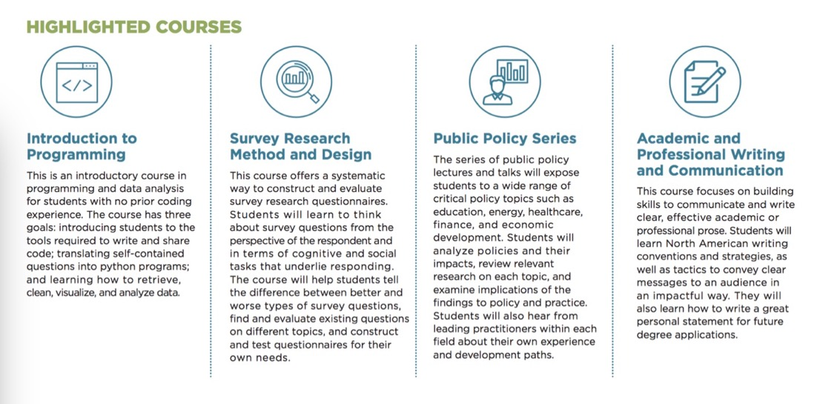

项目申请
- 项目费用：$9500（包含学费、住宿及用餐等，学生需自行负担往返机票）
- 项目时间：2018年7月16日至8月10 日（四周）
- 地点：芝加哥大学
- 可申请人群：满18岁的在读本科生或硕士生，且在项目开始前（2018年7月）至少已有一年的本科在读时间。本科所学专业不作限制。
- 申请材料：
  - 英文个人陈述 Motivation Statement (限300字以内)
  - 短文论述 (one short essay)
  - 本科成绩单
  - 英文个人简历（限一页）
  - 托福或雅思成绩单 （如无法提供，需提交额外的申请材料详见申请网站信息）

- 申请平台： 详见项目网站https://www.harris-summerscholar.uchicago.edu
- 申请时间：
 | Deadline | Notification | Deposit Due
Early Action | Feb 28th , 2018 | Mid March | April 1st, 2018
First Round | Mar 28th, 2018 | Mid April | May 1st, 2018
Second Round | Apr 30th, 2018 | Mid May | May 31st, 2018

项目推广平台
- 项目网站：https://www.harris-summerscholar.uchicago.edu
- 项目联络邮箱：harris-summerscholar@uchicago.edu
- 微信平台：芝加哥大学北京中心 (uchicago_cib)

图片集锦供参考

