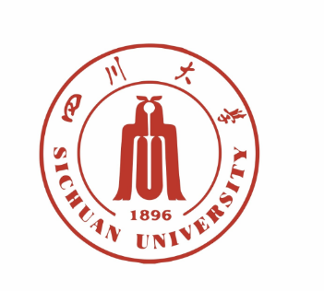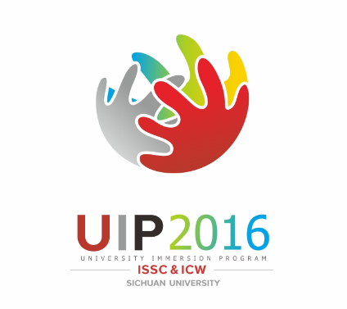 |  |  |  |  | For official use only  International Office Ref  □□□□
Application Form for the 2016 University Immersion Program (UIP)
Section A. Personal Details
Please enter your name exactly as it appears on your passport or other official document.
FAMILY NAME |  |  |  |  |  | PHOTO
FIRST NAME
MIDDLE NAME(S)
TITLE (Mr, Mrs, Ms, Miss, etc.)
GENDER |  | MALE□ FEMALE□
DATE OF BIRTH |  | day_ _ month _ _ year _ _ _ _
PASSPORT No.
UNIVERSITY
RESEARCH FIELD
Section B. Contact Information
ADDRESS
CITY |  |  | POSTAL/ZIP CODE
STATE |  |  | COUNTRY
EMAIL |  |  | PHONE
Section C. Academic Qualifications
DATE | UNIVERSITY/INSTITUTE |  |  | DEGREE
Section D. Professional Experience
DATE | UNIVERSITY/INSTITUTE/COMPANY |  |  | TITLE
Section E. Course Description
COURSE NAME | COURSE DESCRIPTION
COURSE NAME | COURSE DESCRIPTION
Section F. Checklist of Application Materials
Your recent academic CV |  |  |  |  |  |  | □
One reference letter from your university or institute |  |  |  |  |  |  | □
One scanned copy of your passport info page |  |  |  |  |  |  | □
Section G. Additional Requirements
- Courses should be given in English. Each course consists of 16 academic hours and each academic hour is 45 minutes.
- Sichuan University will review your application and respond before middle of April , 2016.
Section H. Subsidies
- SCU will provide15,500 RMB for each course（Before taxes）
- Local accommodation will be provided by SCU
- Your international airfare (economic class) to Chengdu will be covered by SCU

Please email your application materials to:
Ms. Zhang Xiaoyuan(Vivian)
Email: UIPSCU@126.com
Tel: 86-28-85468896
International Office
Sichuan University
No.24, South Section 1, Yihuan Road,
Chengdu, 610065, P.R.China

